Tranxfer

Tranxfer is the tool we use to receive documentation from the customer in a safe environment.
The sender in Tranxfer must be always the GDPR Mailbox, so that the response from the customer lands always in the mailbox – and not an indvidual address.

Another important reason to select always the Mailbox in Tranxfer is that the customer cannot see the individual email address from the agent and responds there directly.

Link: Tranxfer - secure file exchange

Tranxfer Steps:

How to request documents from the customer?
- Agent creates an outbound email using the template that corresponds to the case. Ex. Manual Review
- In Tranxfer the agent must click in Tranxfer Link (right upper corner) > Receive.
- This screen will pop up:

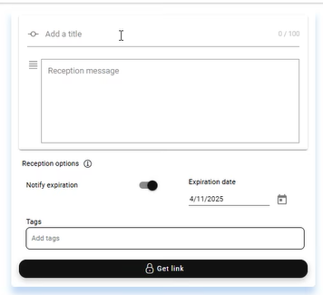

- The agent must add a title: For the title we will use the Customer ID so that the customer receives the reference
- -The agent must click on Get a Link (the black button). A link will be generated. Once the link has been generated, the agent must be pasted in the outbound email where the yellow part for the link is. (LINK TRANSFER)

How to send documents to the customer?
- Agent creates an outbound email using the template that corresponds to the case. Ex. Right of Access
- In Tranxfer the agent must click in Tranxfer Link (right upper corner) > Send.
- This screen will pop up:
- The agent must drop the documents in the right upper section (Add or drag files here)
- Select the issuer (left upper corner)
- Add a title (we use the subject of the inquiry)
- Add the message (eg.Right of Access Template)
- Click on “Get link” (right bottom corner), We will use that link in the email we have already prepared.

General Scenarios:
- Customer does not reply to a Tranxfer request: After 15 days of the Tranxfer request the link will expire and the customer will not be able to use it any longer. Whenever possible, the corresponding Excel file must be updated informing the customer did not reply and that the Tranxfer linked expired. The date to be taken as a reference for the calculation is the one the agent updated when he/she/they entered the information in Excel as the customer was contacted.
- Customer replies: for the process where documentation is required, the agent has available in the corresponding process how to share the documentation with Backoffice. Normally, the documents are shared via Sharepoints in the folders created for the specific cases. Every case should have its own folder inside those folders, named with the Customer ID + Name of the customer

